# Automated Calibration using ModelMate and UCODE.

Richard Winston, July 2013.

**Required materials**

* Manually calibrated model
* MODFLOW-2005
* ModelMuse
* ModelMate
* UCODE-2005.
* GW_Chart

We will start with the trial-and-error calibrated model we created last time. Here was the distribution of Kx that I had when we finished the class. You might have a different distribution.

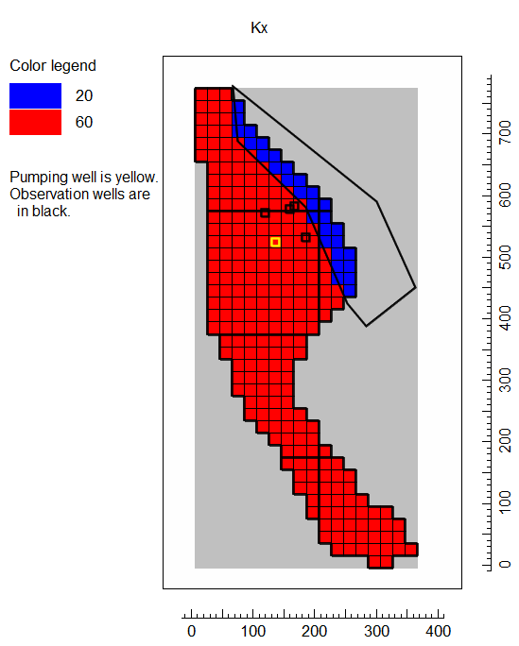

Here is what the observed and simulated values look like when plotted vs. time – not too bad but not great either.



I changed the zonation to what’s shown below and manually calibrated the model. I felt this was a bit better fit. (You might or might not agree that this is a better fit.) I used this as the starting point for my automated calibration using UCODE.

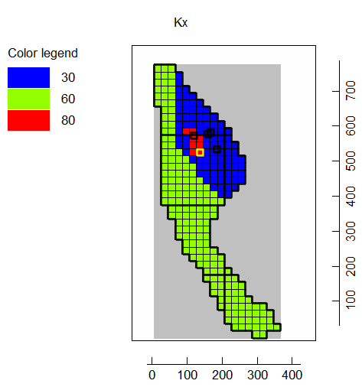



To calibrate the model with UCODE, I first needed to define some parameters. To do this, I selected Model|MODFLOW Packages and Programs and on the pane for the LPF package, I changed the number of HK parameters to 3 and assigned the parameters names and values. I also selected Use Zone for each of the parameters.

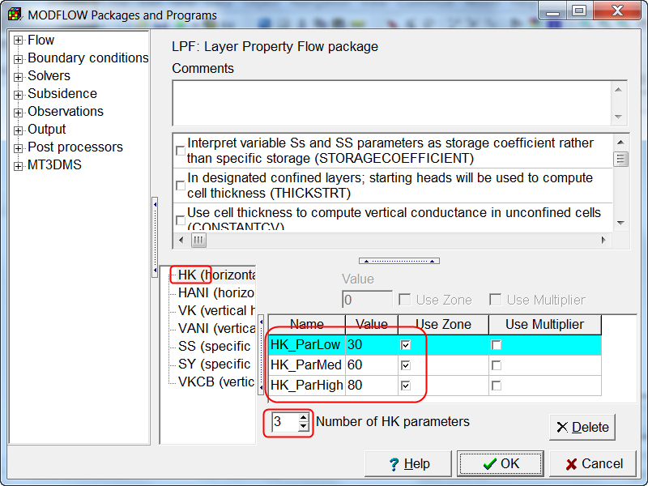

When MODFLOW uses parameters to define the hydraulic conductivity, the value that is assigned is the sum of all the parameter values that are used in that cell times the multiplier array values (if used) for those cells. Zone arrays are used to define which parameters are used in which cells. For example, suppose both HK_ParLow and HK_ParMed were used for a cell. The value of hydraulic conductivity for that cell would be 30+60 = 90. For this example, we only want a single parameter to apply to each cell.

ModelMuse allows you to define which parameter applies to each cell using a separate Boolean (True/False) data set for each parameter. To make sure each parameter is applied to one and only one cell, we will define a new data set called ZoneNumbers in the Data Sets dialog box and use it in formulas for each of the data sets for the parameter zones.

Select “Data|Edit Data Sets…” and click the “Add” button to add a new data set. Name it “ZoneNumbers” set the type to integer and the Orientation to 3D. Set the default formula to 2.

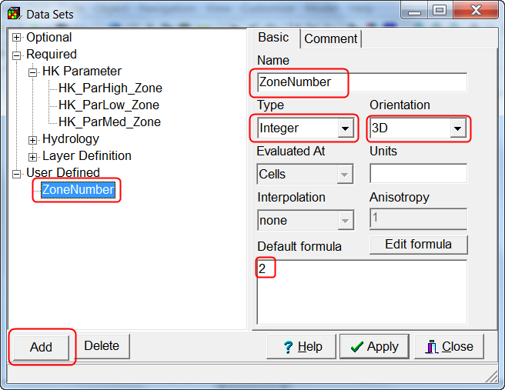

Set the default formula for HK_ParHigh_Zone to “ZoneNumber = 3”. Set the default formula for HK_ParMed_Zone to “ZoneNumber = 2”. Set the default formula for HK_ParLow_Zone to “ZoneNumber = 1”. Click Apply when you are done. Now you can use objects to set the value of the ZoneNumbers data set. You can see the resulting values of Kx by coloring the grid with Kx. (When parameters are used, ModelMuse uses the same method as MODFLOW to calculate the value of Kx.)

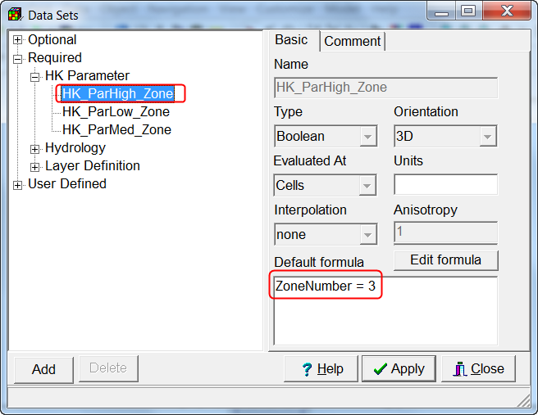

Another change I made was to change the way the observations were treated so that only the first value at any location was treated as a head observation and the rest were treated as drawdown observations. To do that, I double-clicked on each of the head observation objects and changed the value of ITT. I also needed to specify values for Statistic and StatFlag. For StatFlag, I chose to use standard deviations. For the heads, I set the value of statistic to 0.3. For the drawdowns I set the statistic to 0.01. (ModelMuse allows you to set multiple values in this table at one time. Just select multiple cells and then set the values in the controls above the table.) To save the changes, click OK.

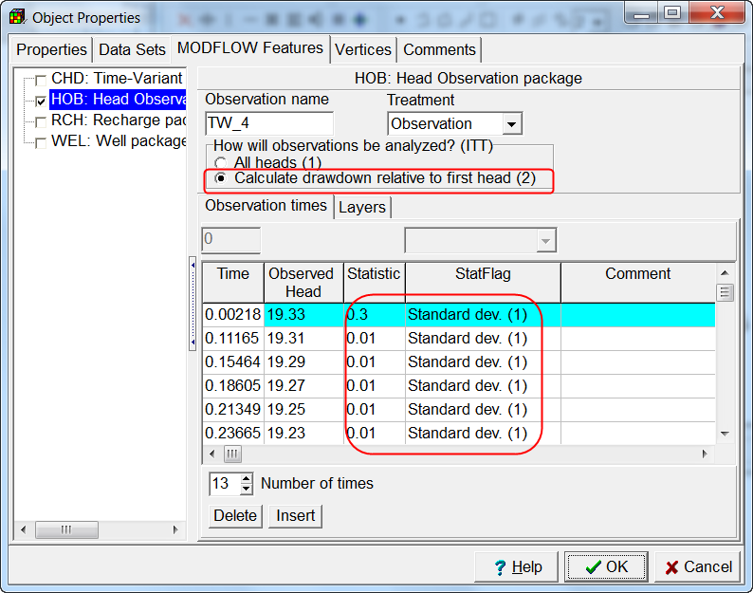

Once you have made these changes, export the MODFLOW input files. You don’t actually need to run MODFLOW but you can do so if you wish.

We will use UCODE to calibrate the model automatically. There is a graphical user interface for UCODE called ModelMate. You can get it from <http://water.usgs.gov/software/ModelMate/>. You can get UCODE-2005 from <http://igwmc.mines.edu/freeware/ucode/>.

ModelMuse can communicate with ModelMate. To transfer data about the model to ModelMate, select “File|Export|Export or Update ModelMate File”. You will be prompted to select a ModelMate file name. If you select a file that already exists, that file will be updated with the information from ModelMuse. If it doesn’t already exist, a new file will be created. By default, the new or modified file will be opened in ModelMate.

You will need to make one change in the ModelMate before attempting parameter estimation. The three HK parameters are assigned to a group named “HK”. You need to make this group adjustable. There is another group named “ParamDefault” that doesn’t have any parameters in it. You can make that group non-adjustable.

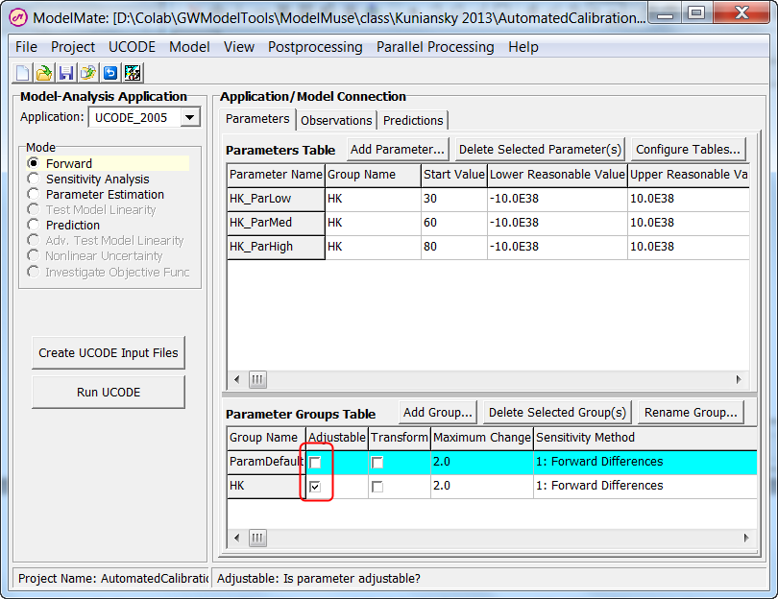

On the Observations tab, you should have 4 head observations and 62 head-change observations. If you don’t, you may have forgotten to change some of the observations to use drawdown instead of all heads.

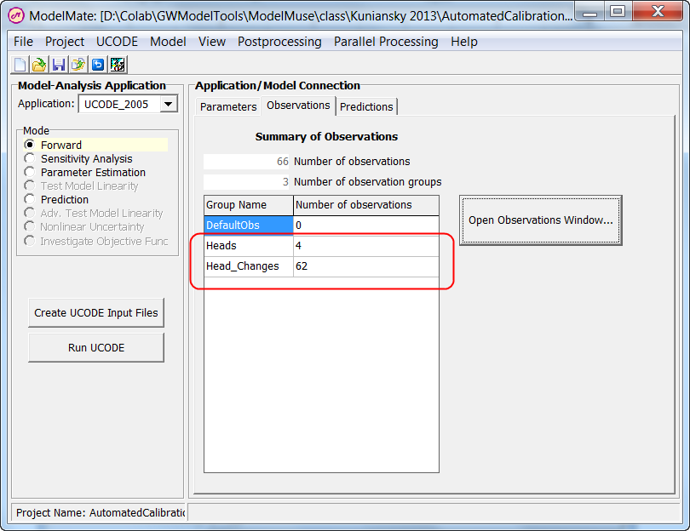

(Optional) Next, select “Project|Project Name and Title” and assign a title for this project.

Select “Model|Create Instruction Files For Observations Defined In ModelMuse”.

(Optional) Select “Model|Model-Output and Instruction Files…” to check that the files have been created. If they have been created, the table should not be empty.

The next step is to check that everything is set up correctly by doing a single run of the model through ModelMate and UCODE. Click the “Run UCODE” button in ModelMate and then click the “Yes” button. MODFLOW should run to completion and terminate normally.

Next change the “Mode” to “Sensitivity Analysis” and run UCODE again. UCODE will generate several files that can be helpful in understanding how sensitive the various simulated values are to changes in the parameter values. For example, you can use GW_Chart to plot the ._sc file as illustrated below. You can see that the results are relatively insensitive to changes in HkParLow compared to the other two parameters.

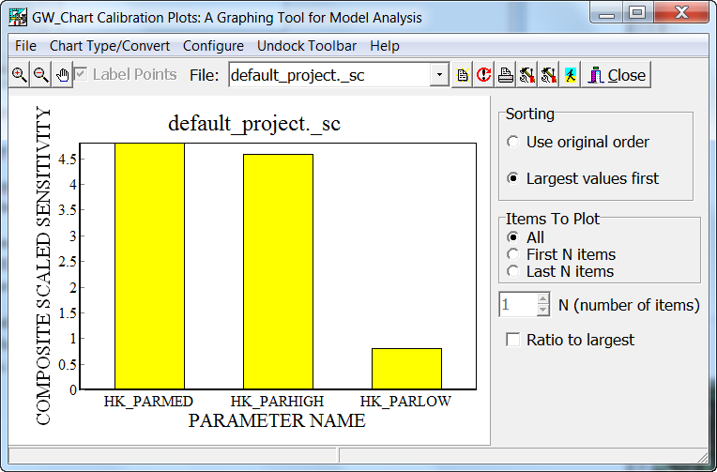

You can also plot the weighted observed values vs the weighted simulated values by plotting the ._ww file. Ideally, the results should lie on a straight line.

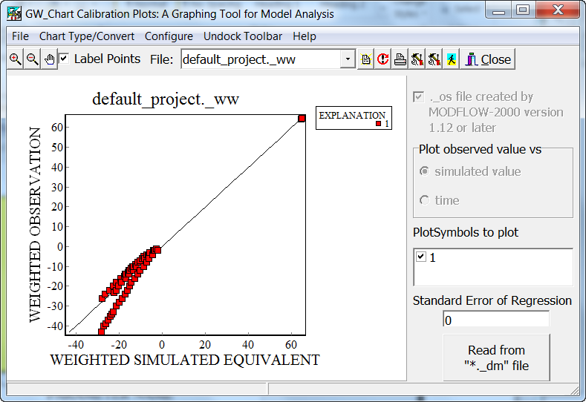

Next change the Mode to “Parameter Estimation” and run UCODE again. You might see an error message like this.

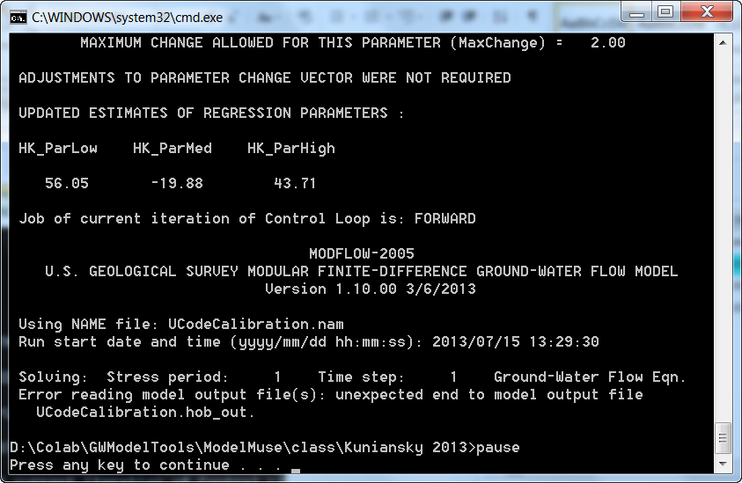

For me, the following fixed the problem.

1. Check the “Transform” checkbox for the HK parameter group fixed the problem. (This prevents negative values of HK being assigned.)   
   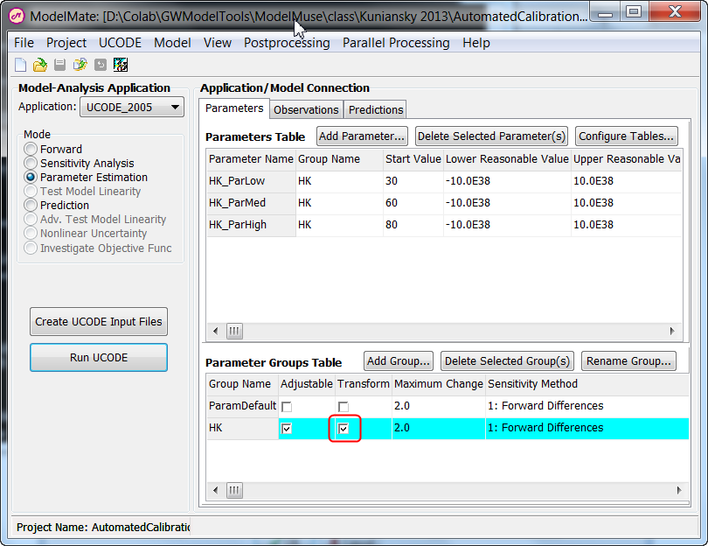
2. Select “UCODE|Parameter-Estimation Settings….”
3. Change “MaxChangeRealm” to “Regression.  
   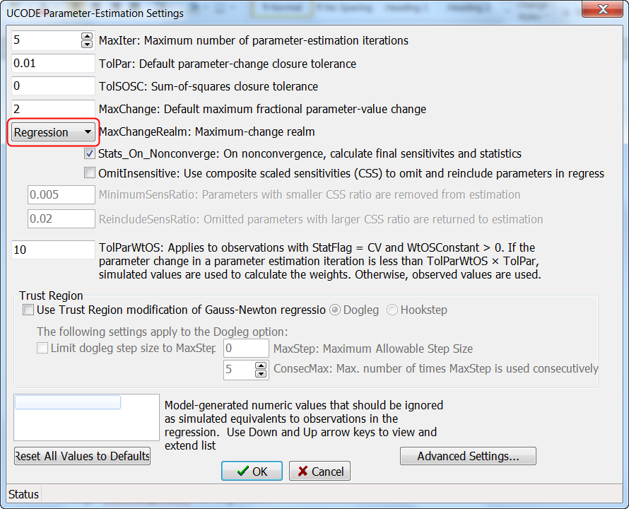

Although this prevented MODFLOW from crashing, the parameter estimation did not converge in five iterations. (The default maximum number of iterations is five.) I changed the maximum number of iterations to 100.

I also changed the zonation to what’s shown below.

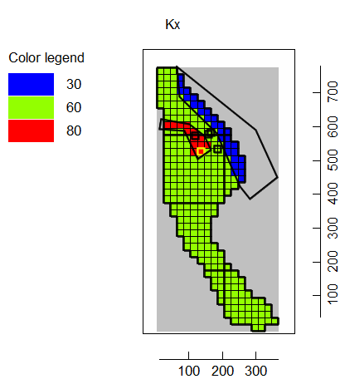

With the calibrated parameter values the model fit is much improved but the sensitivity of the HK_ParLow parameter is almost zero.

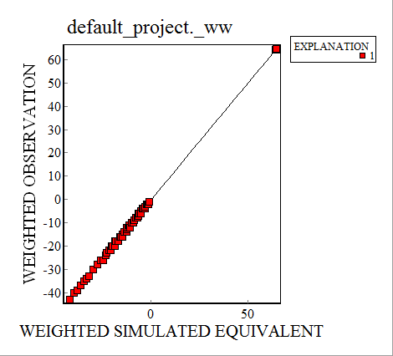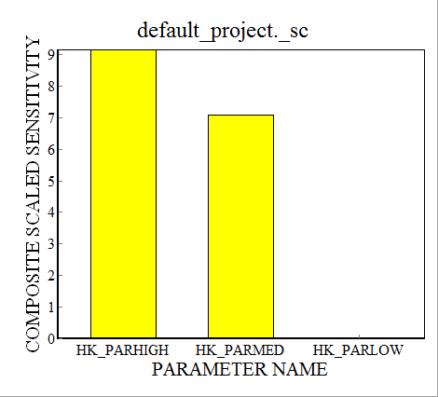

The final parameter values are printed in the main UCODE output file. To see it, select “View|UCODE Main Output file.”

|  |  |  |
| --- | --- | --- |
| HK_ParLow | HK_ParMed | HK_ParHigh |
| 0.1371E-05 | 17.26 | 54.80 |

We now have a calibrated model but not necessarily a good model for making predictions. Here are some limitations of this model.

1. I have no observations in the low hydraulic conductivity zone so my information about it is not very good.
2. I didn’t use the slug test data when setting up the zonation. Maybe I could have improved the zonation by using it.
3. I didn’t use information about depositional environments when setting up the zonation. Instead I just changed the zonation until I got something that converged and gave halfway reasonable values for the parameters. Maybe I could have improved the zonation by using information about depositional environments.
4. I only have observations relatively close to the pumping well so predictions about locations further away from the pumping well are problematic.

I think this calibrated model is a starting point for an improved model rather than a final product. There are undoubtedly other ways I could have set up the zonation that could have been calibrated just well as this model. Using series of such calibrated models might give more insights about the uncertainties in the predictions made with such models.